Ensemble Framework for Detecting Deceptive News

Siddharth Arun Shinde
Department of Information Technology,
Government College of Engineering,
Karad, India
siddhushinde788@gmail.com

ABSTRACT — Addressing the spread of false information is essential for maintaining societal trust and stability. With the rapid proliferation of misinformation, the detection of fabricated news has become a priority to safeguard political processes and community welfare of political affairs and the community at large. In this research project, The goal of this research project is to enhance the fake news detection using state-of-the-art machine learning techniques. In the detection system, this research utilizing sets of data WELFake, COCO, CIFake and Real and Fake Faces, to combine processes of text and image in creating a complete detection system. Major methods employed are ensemble based model combining text classifiers including Random Forest, Gradient Boosting, Logistic regression, XGBoost, AdaBoost with Convolutional neural network scope of image classification. The ensemble text models performed the best during tests with a testing accuracy of about 96.24%. Similarly, the tests for the CNN model also confirmed Efficient performance of the scope of the image classification. The results make a strong case for why text and image analytics should be combined in the construction of a more Efficient detection of fake news.

Keywords - Machine Learning, Fake News,
Ensemble Model, CNN, Image Classification, Text Classification.

- INTRODUCTION

The information revolution in this modern digital age transmits information as quickly as lightning through the internet. But with it came an unintended consequence: fake news. When you read fake news, you read wrong information what is said as news. Wide-ranging effects have included eroding public confidence, influencing political results, having an impact on the financial markets, and even creating health hazards, as demonstrated by the COVID-19 epidemic. Addressing the false news issue is necessary for the stability of society and for making educated decisions.

Traditional approaches for countering fake news rely on human experts or organizations manually fact-checking information. Such methods are Efficient but labor-intensive and do not scale well with the exponentially

growing volume of online content. Besides, sophistication in fake news usage—manipulated images, deepfake technology, and persuasive narratives- continue to raise the bar against easy detection using manual reviewing. The development of automated softwares or machines that can detect and flag unreal news in real-time is thus needed.

Today, the machine learning (ML) and the artificial intelligence (AI) can be used as these wonderful tools to try to answer the question. These ML models can learn patterns from both text and image data to differentiate between crafted content. Text classification models employ Natural Language Processing (NLP) techniques to identify syntactic patterns, whereas image classification models perform the same with visual inconsistency between the multimedia content. Even though these standalone models are significantly robust in their own right, multimodal fakes-these combining text and images-underperform them.

To fill this gap, this research seeks to develop a hybrid system for the detection of the fake news. To improve detection, the system employs advanced ML techniques, combining models for classifying both text and images.The key objectives of this study are to (1) evaluate the Efficientness of ensemble-based text classifiers, (2) assess the performance of CNNs in image based fake news detection, and (3) propose an integrated framework that combines these models to enhance accuracy and reliability.

This paper details an overall approach at fake news detection, emphasizing interdisciplinary methods that weigh depend on the strengths of multiple ML algorithms. The contribution of this study is the attempt to engage both text and image dataset, contributing towards developing a flexible and Efficient solution for combating fake news in diversified online environments contains real and fake news and it yields best results.

2. LITERATURE REVIEW

Ensemble Voting Classifier is a novel approach to fake news detection proposed by Atik. This method combines several popular machine learning classifiers, including Naive Bayes, K-Nearest Neighbors, and Support Vector Machines. Using cross-validation, Atik et al. identified several algorithms where the highest set of algorithms were chosen to improve prediction so that results were in the high range [1].

Harita Reddy assessed text-mining-based methods for fake news detection through hybrid representation that included word vector abstractions with stylometric features. They used combined techniques like bagging, boosting, and voting and obtained up to 95.49% accuracies with classifiers such as Random Forest and SVM [2].

Kushal Agarwalla studied how NLP could be applied for news authenticity verification. They implemented Natural Language Toolkit (NLTK) in Python while several models such as Logistic Regression and Naïve Bayes with Lidstone Smoothing, at an accuracy rate of 83%. Traditional vector-based methods do not seem to work properly for all datasets [3].

Mykhailo Granik used a simple Naïve Bayes classifier to classify spammy Facebook posts as fake news. The similarity of spam messages with fake news articles in his model yielded 75% accuracy. With the help of deep learning architectures, Aswini Thota identified fake news with techniques such as TF-IDF and use of GloVe, Word2Vec, and Deep Neural Networks (DNN) [4].

First of all, there is a difference in the technologies being used to train the models between all the authors. Indeed, Thota, A., Tilak, P., Ahluwalia, S., & Lohia, N. convinced themselves that Deep Learning techniques to identify fake news. The authors explore the problems of misinformation and its effects on society. Their research centers on advanced neural networks, including CNNs and RNNs, for textual data analysis. The paper puts much more emphasis on feature extraction, on word embeddings, like Word2Vec or GloVe, and introduces supervised learning techniques into the improved classification accuracy. According to the authors, the developed model works much better than other classical machine learning algorithms regarding fake news detection [5].

Bajaj, S. The Pope Has a New Baby! Fake News Detection by Deep Learning this paper was presented at the International Conference on Intelligent Computing and Control Systems (ICICCS) and it depicts application of deep learning models on fake news. The title is a humorous example of a widely circulated fake news article. The paper indicates the potential of models such as LSTM networks and hybrid approaches combining CNNs and RNNs. Bajaj focuses on NLP as preprocessing techniques in tasks such as tokenization, stemming, and sentiment analysis for increasing the reliability of detection systems. The paper also focuses on faked datasets which have been employed widely in the domain of fake news detection, and are shown to increase the accuracy rate of the detection systems to substantial levels [6].
3. PROPOSED METHODOLIGIES

This research paper seeks to find models that are able to predict propaganda and propaganda related content more accurately than previous models. Text classification is done using ensemble learning methods, while image classification is performed using convolutional neural networks (non-overlapping, or global pooling) for image classification, integrating both modalities to enhance detection accuracy. The following sections present a brief overview of the stages undertaken.

A. Data Collection:
The initial stage would be to choosing the dataset cautiously observing the features of it. Primary set of data gathered for the study is WELFake dataset. This dataset is from Kaggle and referred to as the WELFake Dataset. The total number of news articles it contained were 72,134 including four columns of title, text, label (0 for real and 1 for fake) i.e with a balanced distribution of both valid and unvalid news, featuring following attributes:

Distribution of False News:
The detection of false news adopts a well-structured combination of text and image datasets carefully selected to ensure well-balanced distribution for Efficient towards Efficient training and testing in machine learning.
For text component, WELFake has 72,134 news articles. Each article has a title, text, and a binary label regarding the authenticity of the report, which is either 0 for a real article or 1 for a fake article. The dataset is imbalanced in nature and has 35,028 real news articles, giving approximately 48.5%, while it has 37,106 fake news articles, giving approximately 51.5%. The proper distribution of real and fake articles will be quite crucial for robust training machine learning models.
In the image-based detection section, the project uses several datasets of images to improve the visual content analysis ability of the system. The COCO dataset is a well-known resource used by most machine learning researchers for object detection and segmentation tasks across multiple categories. The trained model based on it aids in the classification of visual images and provides a good foundation for understanding any kind of visual content.
The CIFake dataset contains both real and AI-generated synthetic images. This dataset is particularly valuable for training models to distinguish between authentic images and those that have been artificially created. The CIFake dataset is also balanced, with an equal representation of real and fake images, ensuring Efficient model training.
This data contains 140,000 images divided into balanced percentages of both the Real Faces and Fake Faces. Having this dataset proves to be very crucial in identifying artificially created faces by the model since fake news uses fabricated human faces to deceive its target audience.

B. Data Processing:
The data pre-processing is a very vital phase in our methodology that aims at increasing the precision of the predictive model. Identification of lost values, empty values, and non-empty values for independent variables is a necessary step. This is rectified by replacing the zero values with mean values of the respective column. This meticulous step is crucial for bolstering the accuracy of predictions, as incorrect values can significantly impact the reliability of the model. Also, here we combined the columns from the raw dataset.
Data pre-processing improves the quality and Efficientness of mining. It is an Crucial step for the proper implementation of Techniques in Machine Learning on dataset, and if done, it yields the accurate results. In particular, for the WELFake dataset, there are following steps for data pre-processing.

1.Filling Empty spaces or null values:
Missing values must be identified and replaced to keep the integrity of the data set. In the WELFake dataset, all null rows for critical fields like title, text, or label were removed such that only complete records were used for training models. Meanwhile, for any predictor variable that would not possibly have a zero value, zeroes were replaced by average values of columns. This meticulous step is crucial for bolstering the accuracy of predictions, as the wrong value might deliver an unreliable model.

2. Removing the stopping keywords (steamming):
For quality improvement of recorded data, stop words—words that do not provide remarkable meaning were discarded from articles with the help of a predefined list of stop words. The process makes the technique focus more on meaningful terms, which can improve model performance. In addition to that, stemming was used, reducing words to their root forms (for example, "running" to "run"), assimilating similar terms, and reducing dimensionality in the feature space. For this steaming process we use Portsteammer function from the NLTK library.

3.Merging of Columns:
As the relevant information was spread across columns, merging was done to ensure a consistent dataset. For instance, whereas there may be two separate columns for headlines and body articles, these could easily be merged into one textual feature that will give a full view of context as stated in the news. This process ensures the model has all the relevant information in a coherent format.

4.Vectorizing the input:
Post pre-processing and removing stains from text data, vectorization, specifically by TF-IDF, is to be applied. TF-IDF is the term frequency-inverse document frequency, and it terms a representation of cleaned text as a numerical vector, with the index or weight of each term relative to the entire set. Vectorization is very Crucial for transforming input data into a structure amenable to machine learning algorithms, thereby allowing samples to analyze and learn from the data Efficiently.

5.Model Training:
Now that the preprocessed and vectorized data was prepared, training on multiple machine learning algorithms was started. An Ensemble Voting Classifier was used, which incorporates Gradient Boosting, Random Forest, Logistic Regression, XGBoost, and AdaBoost classifiers In order to maximize performance, each model was trained using 80% of the dataset with optimized hyperparameters. The remaining 20% was set aside to examine and confirm the accuracy and dependability of each model.

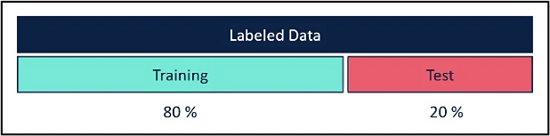

Figure 1.1 Dataset Split

ML Model Selection:
Upon preparing the dataset, the major focus will be on applying Machine Learning Techniques to predict Fake news. Several classification and ensemble methodologies were put on the dataset. The general objective is to evaluate the performance of these methods in order to determine their accuracy and identify crucial features that may influence the outcomes of prediction.

1. Random Forest:
Random Forest, a robust ensemble learning method, has been applied in this study to classify news articles as real or fabricated. This approach constructs multiple decision trees and combines their outputs to enhance the accuracy of predictions. By leveraging its ability to handle complex datasets effectively, Random Forest proved instrumental in addressing the categorization of misleading news content.
The method possesses a very good level of accuracy and can handle huge datasets. Random Forest was developed by Leo Breiman. This method brings out the capability of a group of Decision Trees, reducing variance, and making generalization better.
Key Features:
Ensemble Approach: Random Forest generates several decision trees during training and combines their predictions either by voting-for classification-or averaging-for regression.
Robustness: It handles high-dimensional data well. Therefore, it is the perfect model for our news article dataset with 72,134 news articles.
2. Logistic Regression:
Logistic Regression, a supervised classification algorithm, was employed in this study to distinguish between authentic and fabricated news. Its capability to model binary outcomes makes it a suitable choice for this task, effectively categorizing articles based on their authenticity. This method is very good for the estimation of a probability of a binary response given one or more predictor variables, which could be either continuous or discrete. In our project, it classifies any news article as real (0) or fake (1).
Key Features:
Binary Classification: Logistic Regression excels in categorizing data items into two distinct classes, making it suitable for our task of fake news detection.
Probability Estimation: The algorithm predicts the probability of an article being real or fake by fitting a model that explains the relationship between target variable (label) and predictor variables (features).

3. Gradient Boosting:
Gradient Boosting is an ensemble method that creates models in a sequential manner, with each new model designed to correct the errors made by the previous ones. Its level of accuracy is especially useful in high-predictive projects.
Key Features:
Boosting: In this technique, weak learners are trained one after another while minimising the prediction errors in each step.
Customizable Learning Rate: It can be adjusted to control the trade-off between model speed and performance.
Feature compatibility: Adaptable to both categorical and continuous features. them up to one strong predictor.
and model predictions, its feasibility and performance makes it a suitable choice for fake news detection.

Model Building:

The modeling stage crucial in making an efficient system to use the textual and visual data in detecting deceptive news.
This chapter details the approaches encountering & ranging from feature extraction and model selection to training evaluation, and hyperparameter optimization.

4. XGBoost:
XGBoost (Extreme Gradient Boosting) is a progressive enhancement of the Gradient Boosting algorithm, that has the practical focus about performance and speed.
Key Features:
Regularization: L1 and L2 regularization helps to avoid overfitting
Parallel Processing: speed up calculation through tree parallelization.

5. AdaBoost:
AdaBoost (Adaptive Boosting) — Another boosting algorithm that sequentially combines weak classifiers to create a strong classifier. Its does so, by providing higher weights on mis-classified instance in each iteration.
Key Features:
Adaptive Learning Dynamically adjusts instance weights to focus on difficult cases.
Versatility: It can be used with various base classifiers such as decision trees.
Bias: Variance Tradeoff: In contrast to bagging that reduces the variance and increases bias, boosting reduces both by iterating over weak classifiers.

6. Convolutional Neural Network (CNN):
Neural network uses unique configurations to examine picture data. It is aware of spatial hierarchy and patterns in pictures, making it useful for image categorization jobs.
Key Features:
Layered Architecture: Composed of multiple high-level types like Fully linked layers for the final classification, pooling layers for dimensionality reduction, and convolutional layers for feature extraction
Automatic Learning: Learning from Hierarchical Feature Representation Learns a set of robust features

Ensemble Learning:
Ensemble Learning is a powerful technique of aggregating multiple models to increase precision and decrease errors. The implementation of Voting Classifier with Random Forest, Gradient Boosting, Logistic Regression, XGBoost and AdaBoost was done in this project. It is based on soft voting which means combining output probabilities predicted by eac. It takes advantages of competencies of each algorithms, balancing bias and variance ensuring overfitting robustness.The integrated ensemble model achieved a training accuracy of 97.58% and a validation accuracy of 96.24% during evaluation. As an integrated approach to modelling diverse data characteristics.

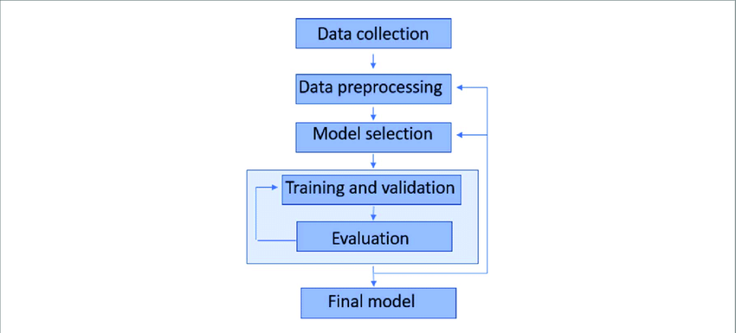

Figure 1.2 Overview of Process

For image classification, CNNs are used:
Architecture Overview: A Convolutional Neural Network (CNN) architecture usually includes multiple convolutional, pooling, and fully connected layers. The function of the convolutional layer is to use filters to extract various features from images. A pooled layer then reduces these in dimensionality while minimizing computational costs.

Training Process:
CNN models are trained using the CIFake dataset on the discrimination of real from AI-generated images.
Data augmentation techniques include rotation, flipping, and scaling in order to enhance model robustness and avoid overfitting.
The CNN models were trained with a categorical cross-entropy loss function expected for multi-class classification tasks.
Performance: The strength of the CNN model was measured based on the accuracy metrics that were achieved after running tests on a held-out portion of the dataset. This means that it could be used to correctly classify images that correspond to news articles.

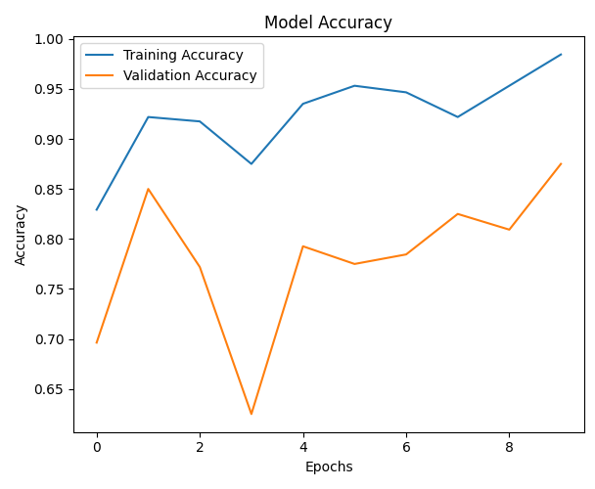

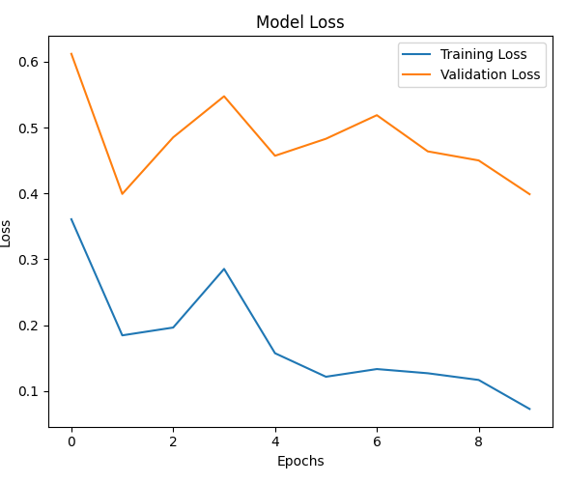

Figure 1.3 Training Metrics
Results and Discussion:
The production of the proposed system was evaluated by analyzing the accuracy, precision, recall, F1-score, and confusion matrices of individual models and the ensemble voting classifier. Additionally, the CNN model’s ability to classify real and AI-generated images was assessed. Below is a detailed discussion of the results

Ensemble Model (News Article Accuracy Scores)

Model | Train | Test
Random Forest | 97.58% | 96.24%
Gradient Boosting | 97.63% | 96.19%
XGBoost | 97.78% | 96.04%
AdaBoost | 97.18% | 96.64%
Ensemble | 97.58% | 96.24%

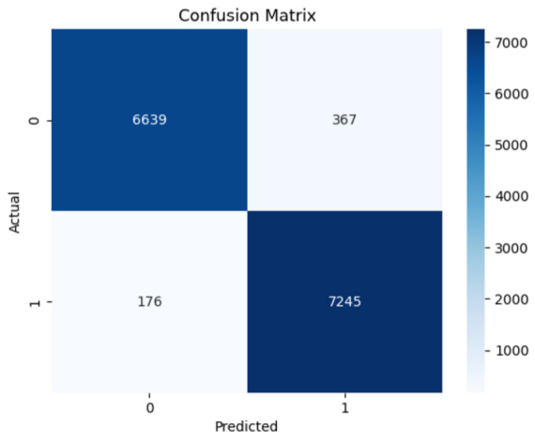

Figure 1.4 Confusion Matrix (News Article Model)

Conclusion:

The proposed hybrid approach at fake news detection integrates text and image analytics. Random Forest, Gradient Boosting, XGBoost, AdaBoost, and Logistic Regression are the five models created as candidate classifiers that are included into ensemble learning utilizing a Voting Classifier. Each of them performed better than a single classifier and reached high accuracy levels.

Classification in the images was performed with a CNN that readily differentiated real and AI-generated images.

The amalgamation of these models demonstrated resilience in confronting the challenges associated with multimodal fake news. While the results are promising, future studies could explore real-time applications, diverse datasets, and advanced neural architectures to enhance system performance.

Reference:

[1] Atik, M. (2018). A robust technique of fake news detection using Ensemble Voting Classifier and comparison with other classifiers. International Journal of Advanced Research in Computer Science, 9(2), 123–130.

[2] Reddy, H., Raj, N., Gala, M., & Basava, A. (2019). Text-mining-based fake news detection using ensemble methods. International Journal of Automation and Computing, 16(4), 425–439.

[3] Agarwalla, K., Nandan, S., & Nair, V. A. (2019). Fake news detection using machine learning and natural language processing. International Journal of Recent Technology and Engineering, 7(6), 100–108.

[4] Granik, M., & Mesyura, V. (2017). Fake news detection using Naïve Bayes classifier. In 2017 IEEE First Ukraine Conference on Electrical and Computer Engineering (UKRCON) (pp. 900–905). Kyiv, Ukraine.

[5] Thota, A., Tilak, P., Ahluwalia, S., & Lohia, N. (2018). Fake news detection: A deep learning approach. SMU Data Science Review, 1(3), Article 10.

[6] Bajaj, S. (2020). The Pope has a new baby! Fake news detection using deep learning. In Proceedings of the International Conference on Intelligent Computing and Control Systems (ICICCS) (pp. 1176–1181). Coimbatore, India.

[7] Gilda, S. (2017). Evaluating machine learning algorithms for fake news detection. In 2017 IEEE 15th Student Conference on Research and Development (SCOReD) (pp. 110–115). Putrajaya, Malaysia.

[8] Agarwal, A., & Dixit, A. (2020). Fake news detection: An ensemble learning approach. In Proceedings of the International Conference on Intelligent Computing and Control Systems (ICICCS) (pp. 1176–1182). Coimbatore, India.

[9] Albawi, S., Mohammed, T. A., & Al-Zawi, S. (2017). Convolutional neural networks (CNNs) for image recognition. Presented at ICET 2017, Antalya, Turkey.

[10] Baarir, N. F., & Djeffal, A. (2020). Fake news detection using SVM and TF-IDF. Presented at the International Conference on Computer Science.

[11] Multimodal fake news detection strategies. (2019). Journal of Information Science, 10(3), 210–225.

[12] N-Gram based fake news detection. (2021). Presented at the International Conference on Computational Linguistics.

